

SCHOOL OF COMPUTING AND INFORMATICS

DEPARTMENT OF INFORMATION TECHNOLOGY

BSC COMPUTER SCIENCE

PROJECT TITLE: PHONEFIXBOT

BY: MELVIN GATHUITA
BSCCS/2024/35996
https://github.com/imgathuita-hub/NLP_mobimend_chatbot/blob/main/Phonefix_bot.ipynb

BIT 4133: NATURAL LANGUAGE PROCESSSING WITH DEEP LEARNING

LECTURER: MR. MICHAEL NYORO

THIS PROJECT IS SUBMITTED IN FULFILMENT OF THE REQUIREMENT FOR THE MOUNT KENYA UNIVERSITY AWARD OF BACHELOR OF COMPUTER SCIENCE.

Table of Contents

WEEK 1: INTRODUCTION TO NLP AND APPLICATIONS 3
FIG 1: GOOGLE COLAB SETUP 3
FIG 4: shows word tokenization output. 4
FIG 5: shows stop word removal keeping only important word that the customer is asking about. 5
FIG 6: shows phonefixbot v1.0 using tokenization and stopword removal. 5
Reflection. 5
WEEK 2: LANGUAGE MODELLING AND SENTENCE STRUCTURE ANALYSIS 6
FIG 1: shows a bigram output which helps detect intent from phrases, not just single words. 6
FIG 2: Show POS tagging which labels each word in a message with its part of speech. 7
FIG 3: shows python code for POS tagging. 8
FIG 4: shows how POS tags are used to extract structured information. 9
FIG 5: Shows upgraded chatbot output v2.0 using N-grams and POS tags. 9
Reflex. 9
WEEK 3: SEQUENCE PREDICTION AND HIDDEN STATE ANALYSIS 10
FIG 1: Shows sequence labelling code 10
FIG 2: assigns labels as B-product as the beginning of the entity type and I-product inside the entity type 11
FIG 3: Shows results of the spacy, a professional library with pre-trained NER model trained on millions of data and understands many patterns. 11
FIG 4: shows results of a chatbot that extracts structured meaning from any customer message. 12
FIG 5: shows our own mini dataset where the real phonefixbot would be trained on labelled data. 12
Reflection. 13
WEEK 4: DEPENDENCY PARSING WITH SPACY 13
Fig 1: show the root verb, object and subject. 13
Fig 2: shows semantic similarity results. 14
Reflection 14
WEEK 5: COMPLETE NLP PIPELINE 14
Reflection 14

WEEK 1: INTRODUCTION TO NLP AND APPLICATIONS

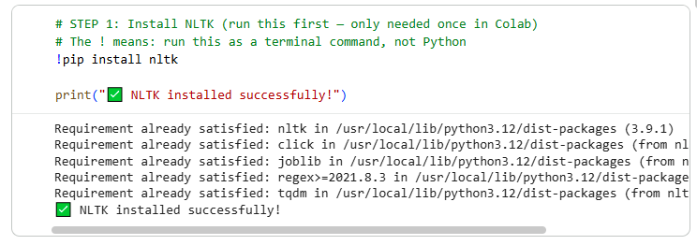

FIG 1: GOOGLE COLAB SETUP

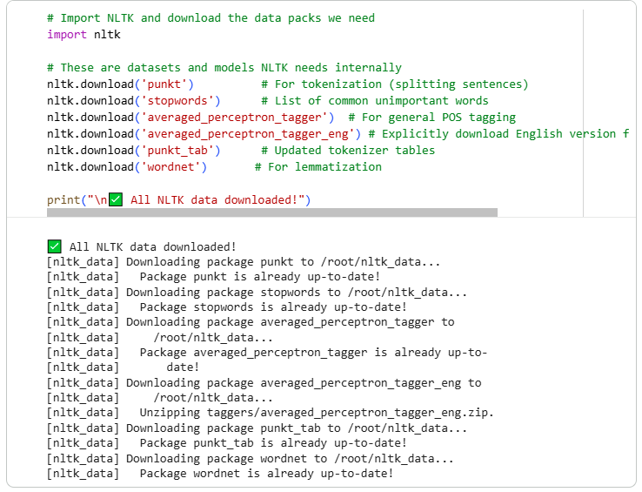FIG 2: NTLK INSTALLATION
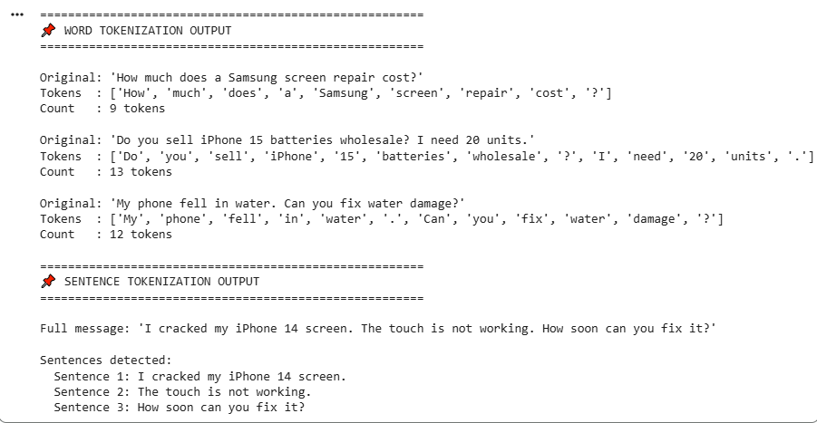

FIG 4: shows word tokenization output.

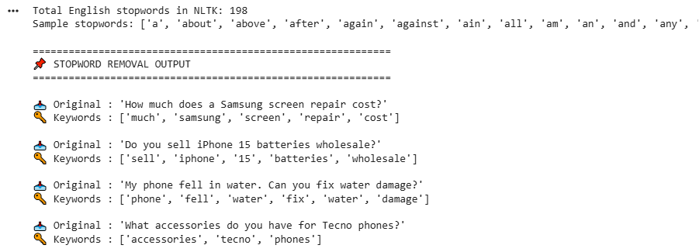

FIG 5: shows stop word removal keeping only important word that the customer is asking about.

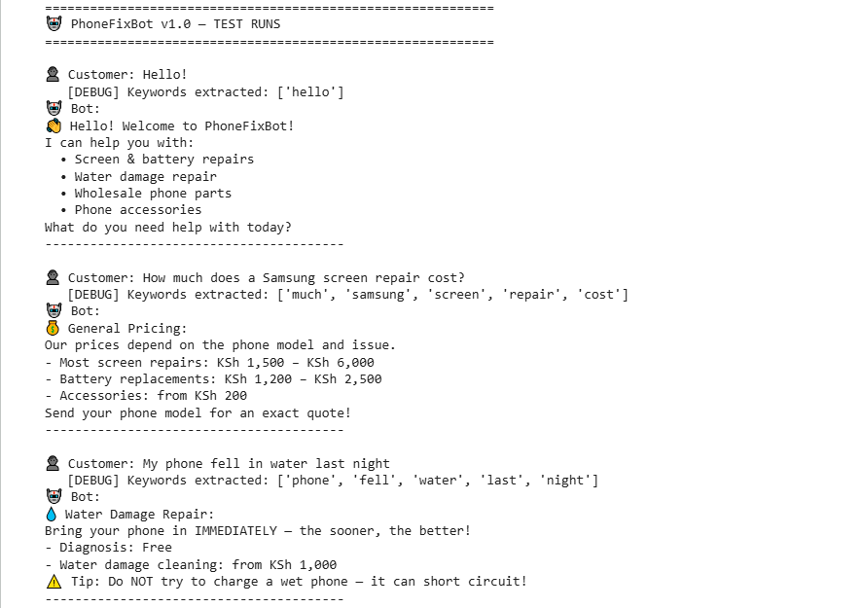

FIG 6: shows phonefixbot v1.0 using tokenization and stopword removal.

Reflection.
This week I installed Python's NLTK library and set up Google Colab as my NLP development environment. I implemented tokenization then applied stopword removal to filter out common words such as 'how', 'does', and 'a', leaving only meaningful keywords. These keywords power a rule-based chatbot that matches customer queries to responses about phone repairs, wholesale parts, and accessories. This demonstrates how raw text is preprocessed before any machine learning can occur.

WEEK 2: LANGUAGE MODELLING AND SENTENCE STRUCTURE ANALYSIS

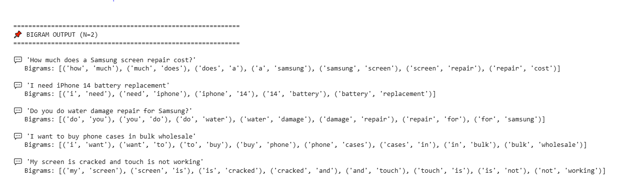

FIG 1: shows a bigram output which helps detect intent from phrases, not just single words.

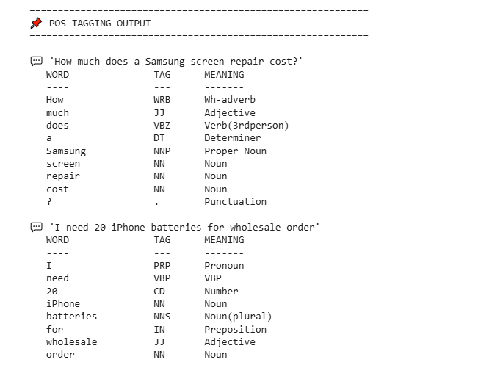

FIG 2: Show POS tagging which labels each word in a message with its part of speech.

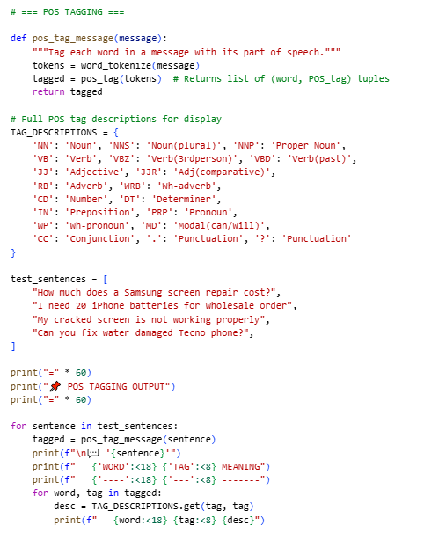

FIG 3: shows python code for POS tagging.

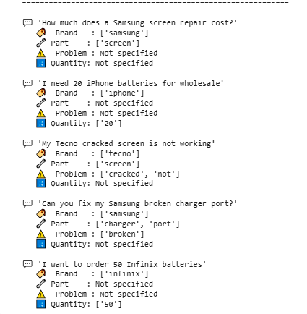

FIG 4: shows how POS tags are used to extract structured information.

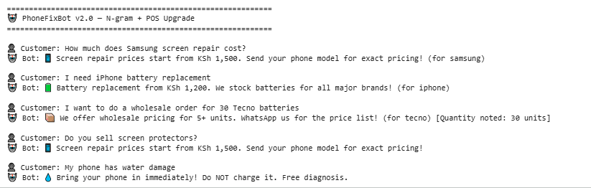

FIG 5: Shows upgraded chatbot output v2.0 using N-grams and POS tags.

Reflex.
This week I implemented N-gram models and POS tagging on customer messages for the PhoneFixBot. Bigrams like 'screen repair' and 'water damage' proved more precise than single keywords for identifying customer intent, since context between adjacent words carries meaning. POS tagging enabled structured extraction of phone brands using NNP tags like Samsung, iPhone, parts using NN tags like screen, battery, and quantities using CD tags like 20, 50 from sentences automatically. The upgraded chatbot can now personalise responses like recognising that '30 Tecno batteries wholesale order' involves a specific brand, part, and quantity.

WEEK 3: SEQUENCE PREDICTION AND HIDDEN STATE ANALYSIS

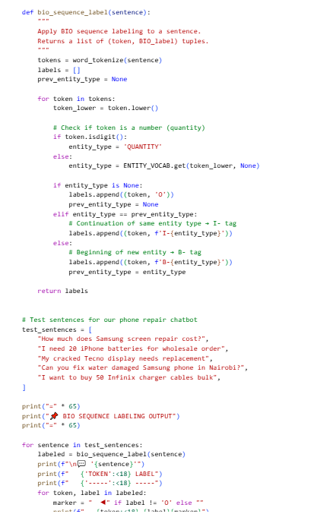

FIG 1: Shows sequence labelling code

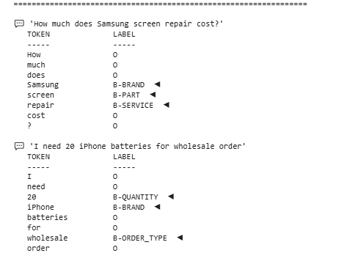

FIG 2: assigns labels as B-product as the beginning of the entity type and I-product inside the entity type

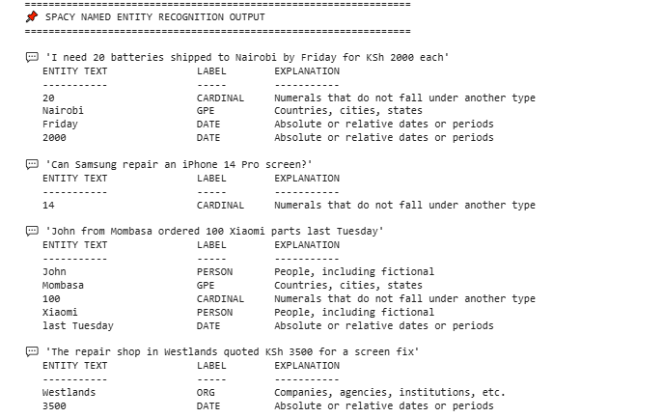

FIG 3: Shows results of the spacy, a professional library with pre-trained NER model trained on millions of data and understands many patterns.

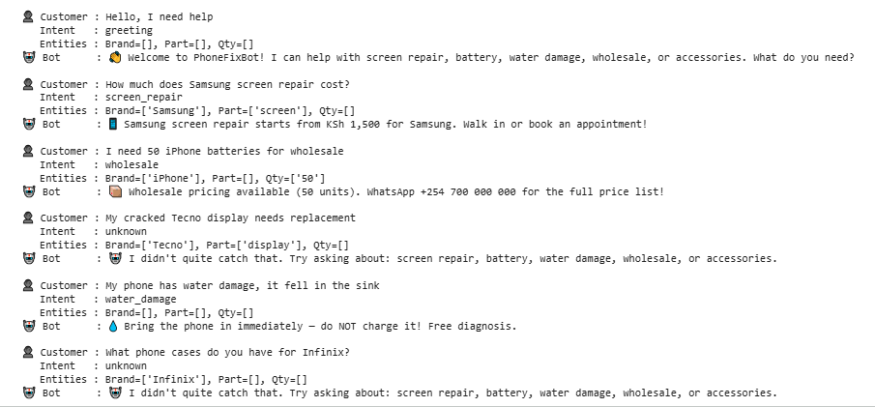

FIG 4: shows results of a chatbot that extracts structured meaning from any customer message.

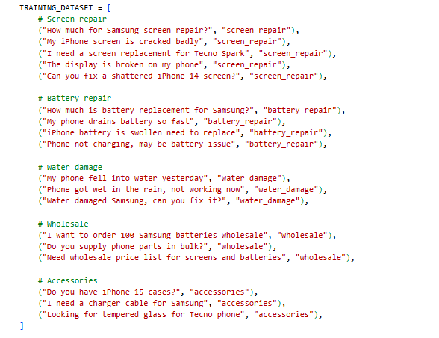

FIG 5: shows our own mini dataset where the real phonefixbot would be trained on labelled data.

Reflection.
This week I implemented Named Entity Recognition and sequence labeling using the spaCy NLP library. This is essential because product names like 'iPhone 14 Pro Max' span multiple tokens. The completed PhoneFixBot v3.0 integrates all three weeks: tokenization, N-gram phrase detection, POS-based grammar analysis, and NER-based entity extraction. The system now identifies brand, part, quantity, and location from raw customer text — enabling personalised, context-aware automated responses for the phone repair business.

WEEK 4: DEPENDENCY PARSING WITH SPACY

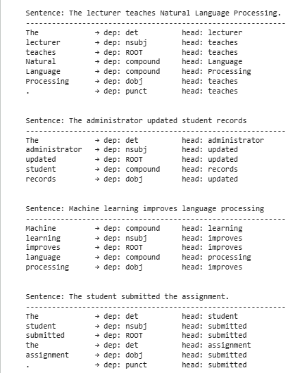

Fig 1: show the root verb, object and subject.

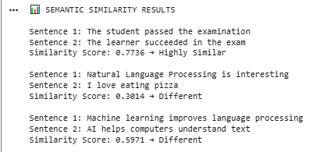

Fig 2: shows semantic similarity results.

Reflection
In Week 4, I explored syntactic and semantic analysis in NLP. Using spaCy, I performed dependency parsing on sentences like “The administrator updated student records” and observed subject-verb-object relationships. I also implemented semantic similarity comparison between related and unrelated sentences. The practical tasks helped me understand how NLP systems analyze grammar and meaning. Key takeaway: Syntax focuses on structure while semantics deals with meaning. This week strengthened my ability to interpret NLP outputs.

WEEK 5: COMPLETE NLP PIPELINE

Reflection

Week 5 focused on integrating NLP techniques and building a mini-project. I completed a full pipeline using NLTK for tokenization, stopword removal, and POS tagging. I also enhanced the rule-based chatbot into a Student Academic Assistant capable of handling greetings, CAT/exam queries, and unit registration. This project reinforced the complete NLP workflow. Challenges included improving response logic.

